Pre-season workouts for sprinters and hurdlers
Week of October 21st
Day 1-
*Dynamic warmup
*See warm up document

*Run for 20 minutes

*Strength and core (see below)
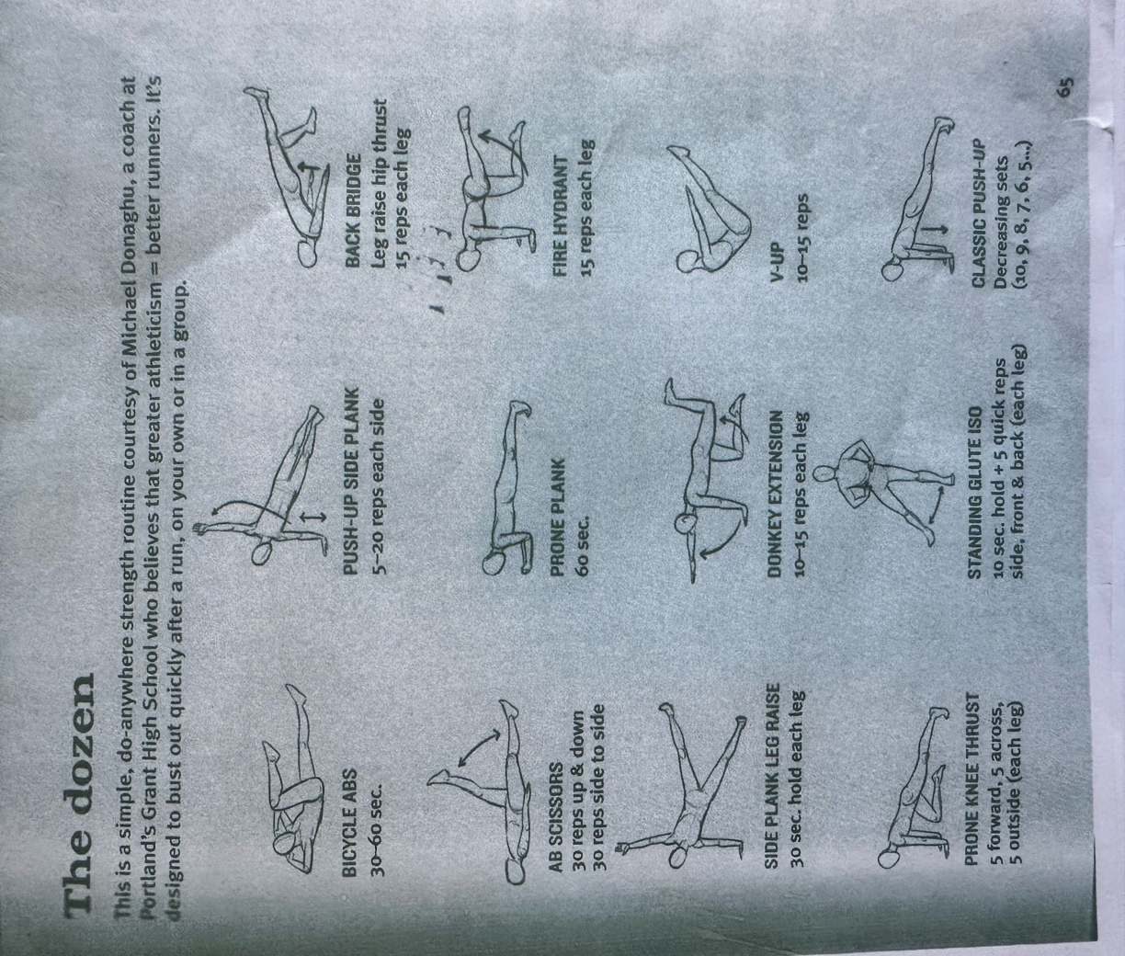

*Static stretching for cool down

Day 2
*Dynamic warm up (skip sprints at the end)
*Start Progressions/accelerations 2 sets of below with 3 min in between each rep and 6-10 minutes in between set ; total sprint volume of 240 meters
-push up position to 20 meters
-lie on back with head closest to the starting line to 20 meters
-sit facing backwards to 20 meters
-falling start to 20 meters
-3 point start to 20 meters
-4 point start to 20 meters

*Cool down
Static stretches

Day 3
*Dynamic Warm Up
*Run for 20-25 minutes
*Do Strength and core from day 1
*Static stretching for cool down

Day 4
*Dynamic Warm up (skip sprints at the end)

*3x4x30 meter sprints using a pushup start; 3 min in between reps 6-10 minutes in between sets; total sprint volume 360 meters

*cool down
Static stretches

